Commissioners’ Journal

2015, THIRTY-SEVENTH MEETING

CRAWFORD COUNTY COURTHOUSE, COMMISSIONERS’ BOARD ROOM
Girard, KS Tuesday, May 19, 2015, 10:00 AM

The Crawford County Board of Commissioners met pursuant to Kansas Statutes

Annotated Chapter 19, Article 2, Section 18 in due and regular session with open doors.

Commissioner Carl Wood served as the presiding officer.

Commissioners Jeff Murphy and Tom Moody were in attendance.

County Clerk Don Pyle and County Counselor Jim Emerson were seated with the Board.

Chairman Wood led the pledge of allegiance.

UNDER THE HEADING BUSINESS FROM A PREVIOUS MEETING
CONSENT AGENDA

On motion (15-147) of Commissioner Moody and the second of Commissioner Wood that the consent agenda be approved including:
- Approval of the May 15, 2015 minutes of the Board of Commissioners.
Yeas: Commissioners Moody, Murphy and Wood
Nays:
Present but not voting:
Absent or not voting:
The motion prevailed and the consent agenda was approved.

SIGNING OF MOTIONS

The County Clerk presented the following motions for Commissioners’ signatures:

Motion 15 | 144 | To recess this open session and go into a closed executive session for a period of not more than 60 minutes to discuss items that could be deemed privileged in the attorney client relationship and to include the Board of County Commissioners, Attorney Terrelle Mock, Dwight Merriam, Karla Chattee, Ted Carey, Evan Seeman and County Counselor Jim Emerson
Motion 15 | 145 | To recess this open session and go into a closed executive session for a period of not more than 30 minutes to discuss items that could be deemed privileged in the attorney client relationship and to include the Board of County Commissioners, Attorney Terrelle Mock, and County Counselor Jim Emerson
Motion 15 | 146 | That the consent agenda be approved including: Approval of the May 12, 2015 minutes of the Board of Commissioners, and Approval of the May 13, 2015 minutes of the Board of Commissioners Special Meeting, and Approval of the accounts payable warrant numbers 556997 to 557285 dated May 15, 2015 in the total amount of $223,058.59

UNDER THE HEADING NEW BUSINESS
CRAWFORD COUNTY BOARD OF HEALTH
PUBLIC HEARINGS AND OPENING OF ANNOUNCED BIDS
MESSAGES FROM THE PUBLIC
MESSAGES FROM OTHER GOVERNMENTAL ENTITIES
MESSAGES FROM APPOINTED OFFICIALS
MESSAGES FROM ELECTED OFFICIALS
PROCLAMATIONS AND ORDERS OF THE BOARD
NEW BUSINESS

Item One: Mr. Jim Emerson, County Counselor, presenting a Real Estate Lease Agreement between Crawford County Board of Commissioners and Kansas State University for property located at 667 S 69 Hwy, Pittsburg, KS. Mr. Emerson stated that this a lease agreement for the part of the Freeto Property Office Building that is used by the Kansas State Extension Office and that this is for two years. It was discussed that this includes the lease renewal for this property and that the lessee pays a portion of the utilities for this building.
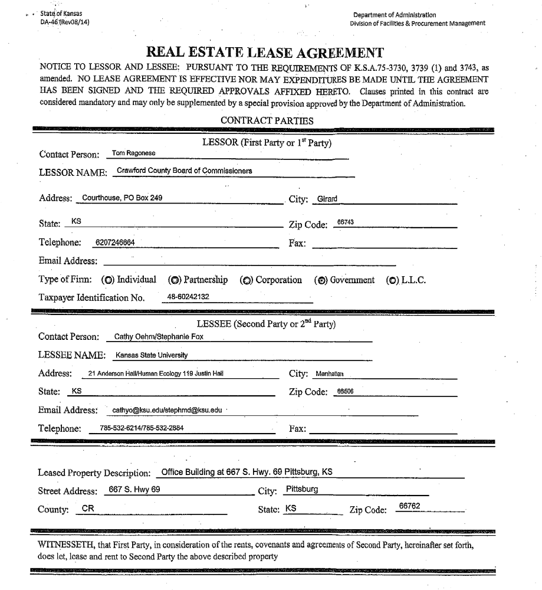
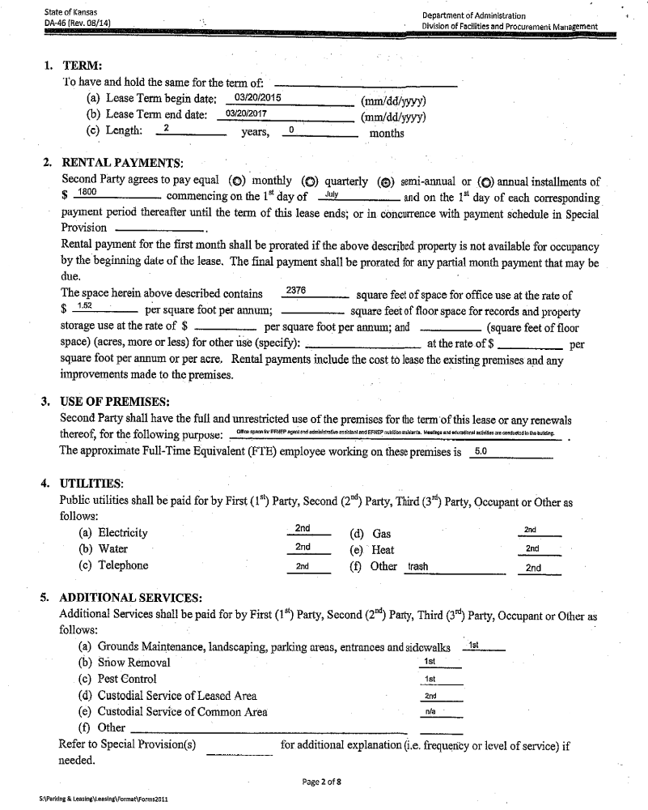
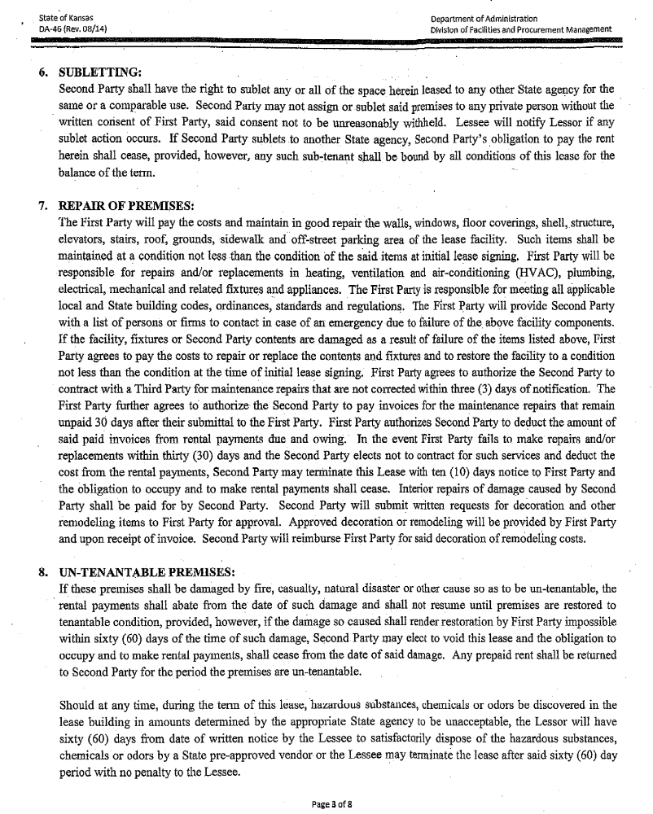
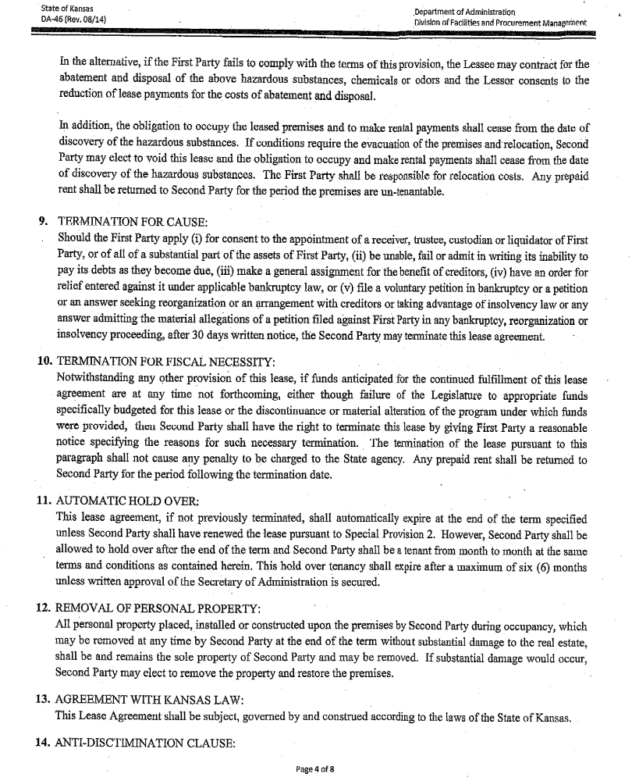
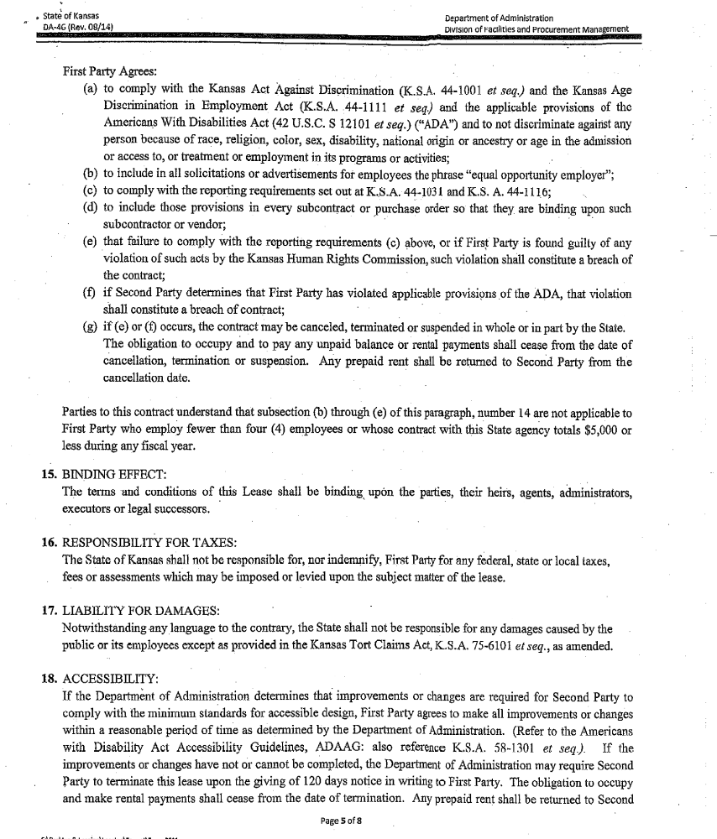
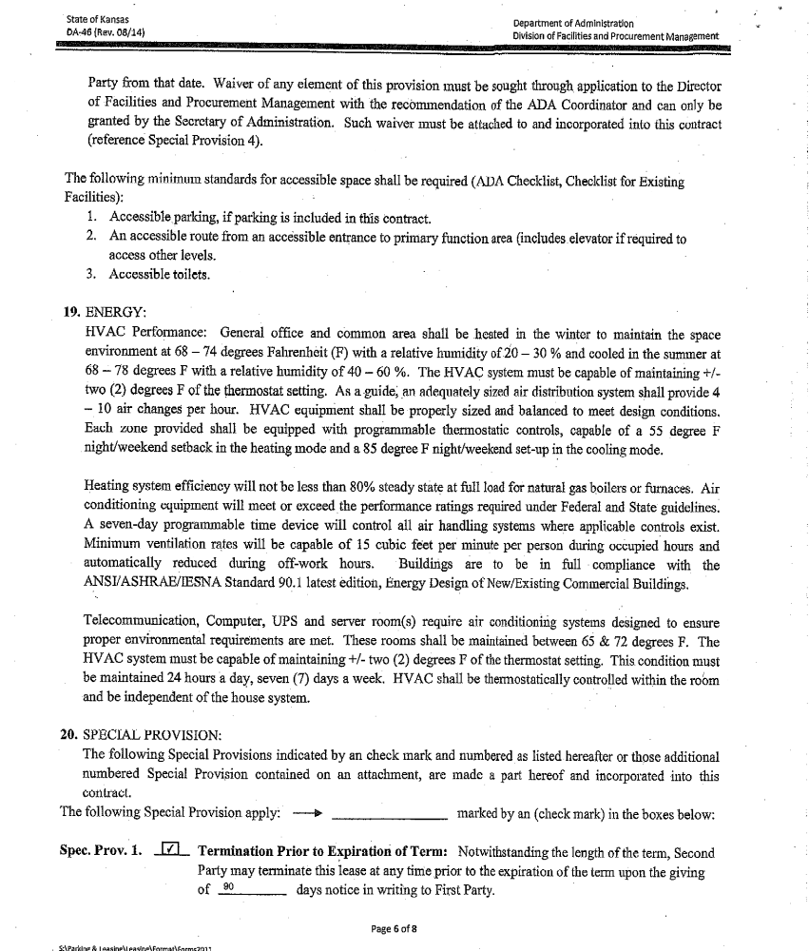
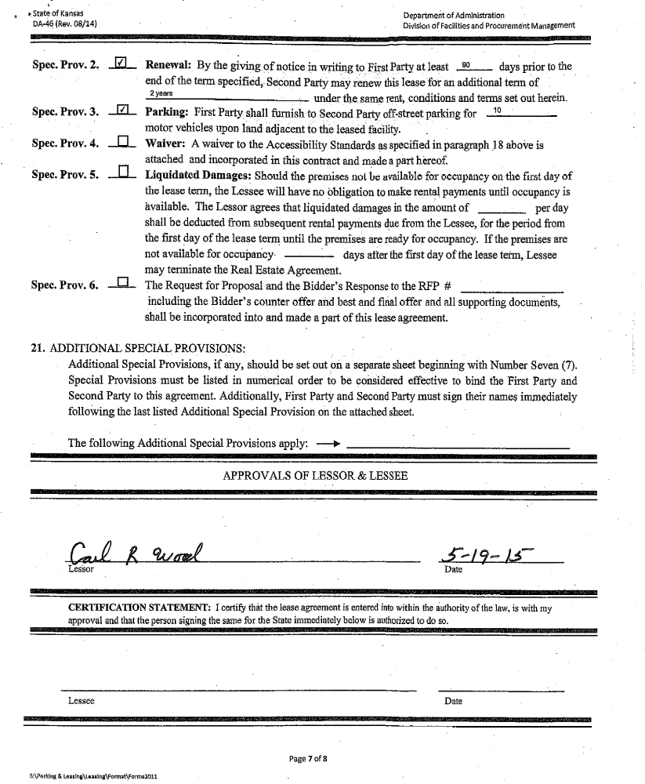
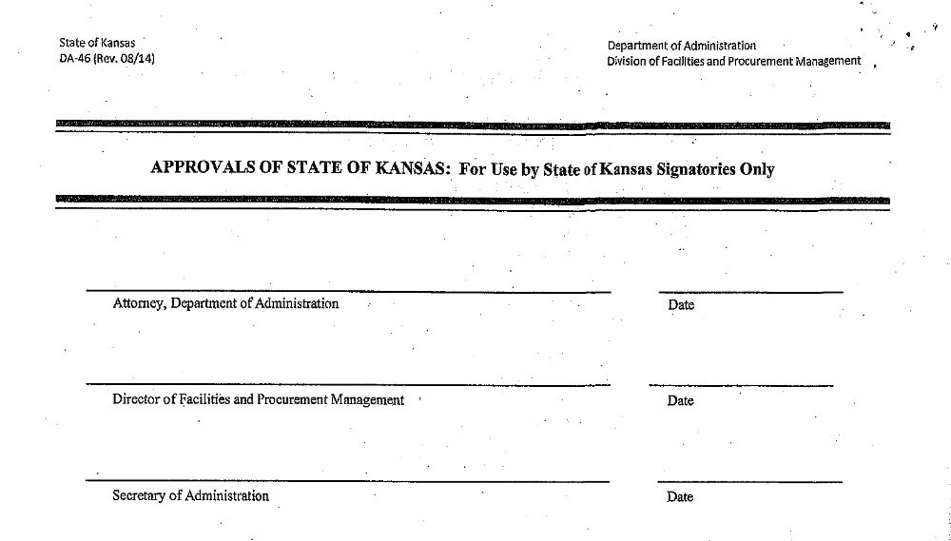

On motion (15-148) of Commissioner Wood and the second of Commissioner Moody to approve the Real Estate Lease Agreement between Crawford County Board of Commissioners and Kansas State University for property located at 667 S 69 Hwy, Pittsburg, KS and authorize the Chairman to sign.
Yeas: Commissioners Moody and Wood
Nays:
Present but not voting: Commissioner Murphy
Absent or not voting:
The motion prevailed.

Item Two: Mr. Jim Emerson, County Counselor, presenting Resolution #2015-016, a Resolution stating support for the development of U.S. Bicycle Route 76. Mr. Emerson stated that the group, KanBikeWalk Adventure Cycling Association, is requesting that the Kansas Department of Transportation designate United States Bicycle Route 76 into Kansas and wants Crawford County’s support in getting this accomplished as it will go through our County. A discussion was held on the signage for the route and what the County’s responsibility would be with the signs.
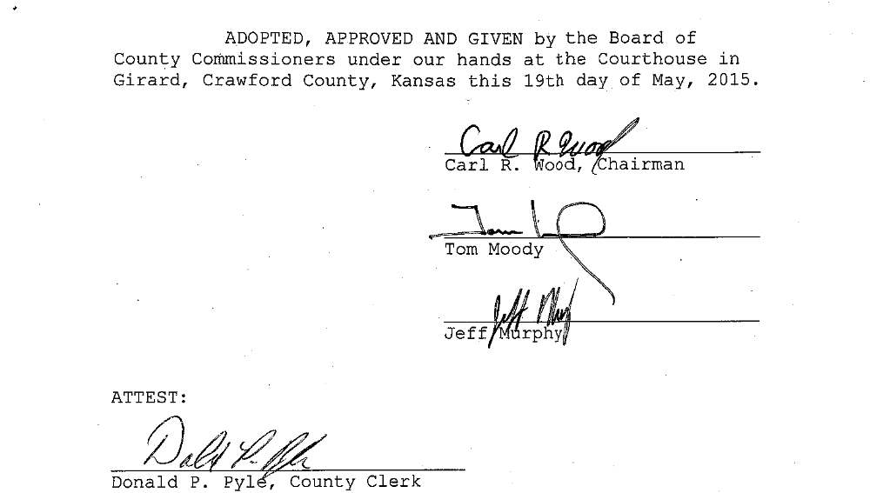

On motion (15-149) of Commissioner Moody and the second of Commissioner Murphy to adopt Resolution #2015-016, a Resolution stating support for the development of U.S. Bicycle Route 76.
Yeas: Commissioners Moody, Murphy and Wood
Nays:
Present but not voting:
Absent or not voting:
The motion prevailed.

Item Three: Commissioner Murphy regarding getting information from the departments on average annual amounts needed to replace equipment. Mr. Pyle discussed an equipment reserve fund and how it would be a part of the departments’ budget process and how the fund would get started. Mr. Pyle will do some further research and report back to the Commissioners.

Item Four: Commissioner Wood regarding some information that he had gotten on the cost of a tractor for mowing. Mr. Wood discussed it with Greg Hite this morning and Mr. Hite will check into the specs for different tractors and report back to him. There was a discussing on the funding of the tractor.

Item Five: Mr. Wood asked about the date of the next back tax sale.

UNDER THE HEADING OLD BUSINESS

Item One: Commissioner Murphy regarding hiring a part-time employee to help with maintenance around bridges in the county. Mr. Murphy was concerned that the wages portion of the Road & Bridge budget was already a little over for this year. Mr. Wood discussed that he hired a seasonal employee so that the county would not need to furnish benefits for this employee. Mr. Moody stated that he had planned on hiring a part time employee at only 25 hours a week. A discussion was held on the drug testing policy.

Item Two: Commissioner Murphy wanted to discuss a map of the locations in the county where rock has been placed this year. There was a discussion of the map and that it would be good to designate roads for the amount of traffic that they have. There was a discussion of how hard it is to maintain all of the county roads and that the amount of traffic on roads needs to be considered.

Item Three: Commissioner Murphy also discussed that he would be working with the staff in the Fiscal Office and with Jim Emerson to review the hiring and evaluation policies of the county. Mr. Murphy stated that he wanted the other Commissioners to be aware of this.

EXECUTIVE SESSION

Under the heading future business and announcements
FUTURE BUSINESS:

ANNOUNCEMENTS:

Item One: May 19, 2015 – 11:30 AM County and City Officials Luncheon hosted by the City of Arma. All three Commissioners may be in attendance.

Item Two: May 21, 2015 – 6:00 PM Annual Chamber Banquet at the Memorial Auditorium in Pittsburg. All Commissioners may be attendance.

Item Three: May 25, 2015 – The Courthouse will be closed in observance of the Memorial Day Holiday.

UNDER THE HEADING MOTION TO ADJOURN
MOTION TO ADJOURN
Item One: Adjournment

On the motion of Commissioner Moody and the second of Commissioner Murphy to adjourn the May 19, 2015 meeting of the Board of Crawford County Commissioners at 11:05 AM and to reconvene at the next regularly scheduled time with open doors.
Yeas: Commissioners Moody, Murphy and Wood
Nays:
Present but not voting:
Absent or not voting:
The motion prevailed.

In Testimony whereof, I have hereunto set my hand and caused to be affixed my official seal and submitted these minutes for the approval of the Board of Crawford County Commissioners:

__________________________
Don Pyle
County Clerk

<>

This submission completed at the Crawford County Courthouse in Girard.
Taken by DPP 05/19/2015 at 11:05 AM/amended BKW 05/21/2015 10:19 AM

