Commissioners’ Journal

2014, NINETY-FIRST MEETING

CRAWFORD COUNTY COURTHOUSE, COMMISSIONERS’ BOARD ROOM
Girard, KS Tuesday, December 23, 2014, 10:00 AM

The Crawford County Board of Commissioners met pursuant to Kansas Statutes Annotated Chapter 19, Article 2, Section 18 in due and regular session with open doors.

Commissioner Bob Kmiec served as the presiding officer.

Commissioners Tom Moody and Carl Wood were in attendance.

County Clerk Don Pyle and County Counselor Jim Emerson were seated with the Board.

Chairman Kmiec led the pledge of allegiance.

UNDER THE HEADING BUSINESS FROM A PREVIOUS MEETING
CONSENT AGENDA
On motion (14-315) of Commissioner Moody and the second of Commissioner Wood that the consent agenda be approved including:
- Approval of the December 19, 2014 minutes of the Board of Commissioners.
Yeas: Commissioners Moody, Kmiec and Wood
Nays:
Present but not voting:
Absent or not voting:
The motion prevailed and the consent agenda was approved.

SIGNING OF MOTIONS
The County Clerk presented the following motions for Commissioners’ signatures:

Motion 14 | 311 | That the consent agenda be approved including: Approval of the December 16, 2014 minutes
Motion 14 | 312 | To adopt Resolution #2014-033, a Resolution Prohibiting the Operation of Trucks and Commercial Vehicles on Portions of 260th Street, Crawford County, Kansas
Motion 14 | 313 | To recess this open session and go into a closed executive session for a period of not more than 15 minutes to discuss personnel matters involving Non-Elected Personnel and to include the Board of County Commissioners, County Counselor Jim Emerson and County Appraiser Mike Montgomery
Motion 14 | 314 | To recess this open session and go into a closed executive session for a period of not more than 20 minutes to discuss personnel matters involving Non-Elected Personnel and to include the Board of County Commissioners, County Counselor Jim Emerson and County Appraiser Mike Montgomery

UNDER THE HEADING NEW BUSINESS

NEW BUSINESS FOR CRAWFORD COUNTY BOARD OF HEALTH

Item One: Ms. Janis Goedeke presenting a 1422 Grant from the Kansas Dept. of Health and Environment. Ms. Goedeke discussed that this grant will require the Health Dept. to work with other local agencies to achieve its goals of preventing obesity, diabetes, heart disease and stroke in Crawford County. It was discussed that this grant is in the amount of $240,000 for 2015 and it has the potential of being renewed for 3 additional years thereafter. It was discussed that the Health Dept. would probably need to hire one person to manage this program but that most of the work will go through local organizations and agencies that are already in place. Ms. Goedeke stated that the state will send out another corrected contract for signature but that she is seeking approval of the grant today.
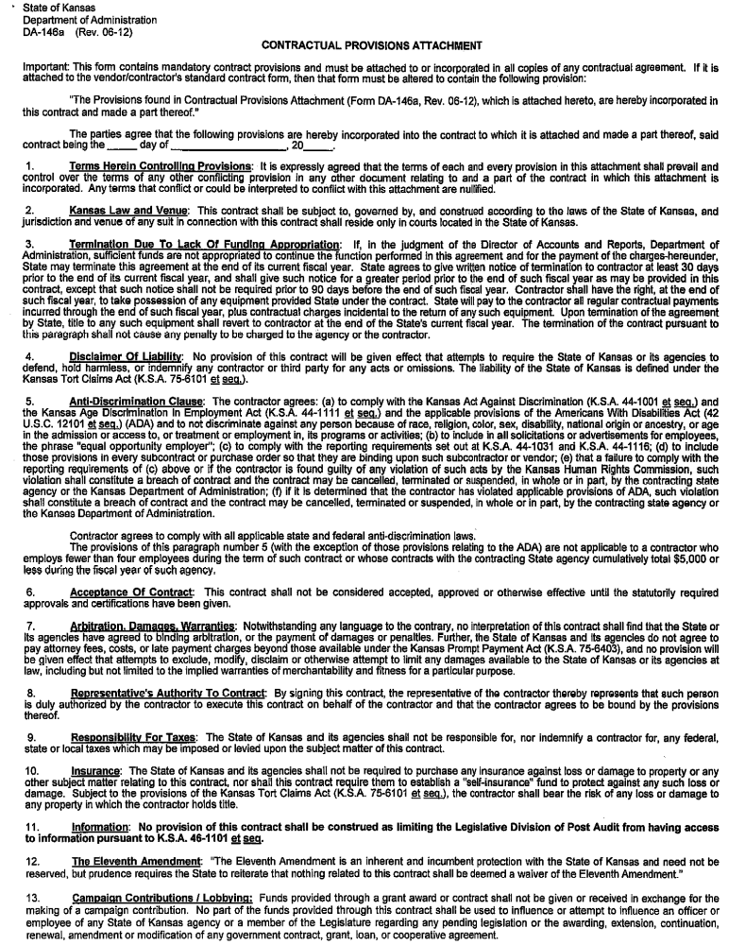
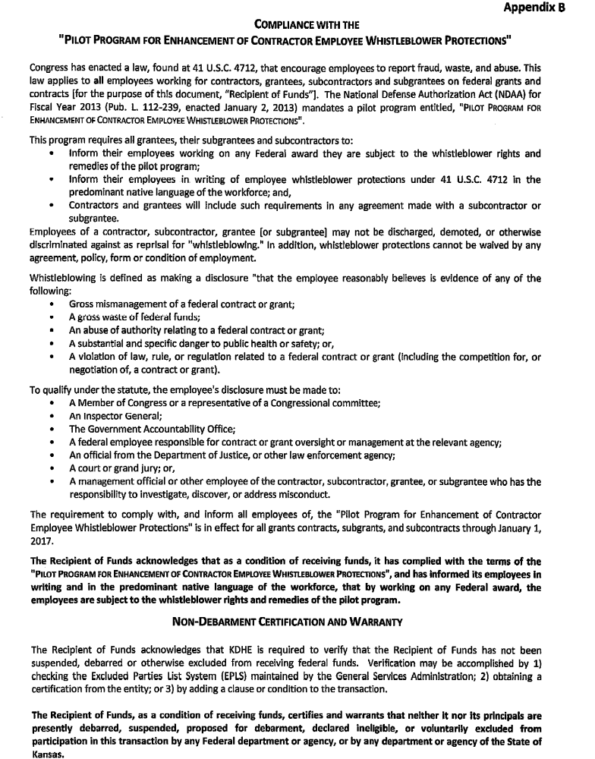
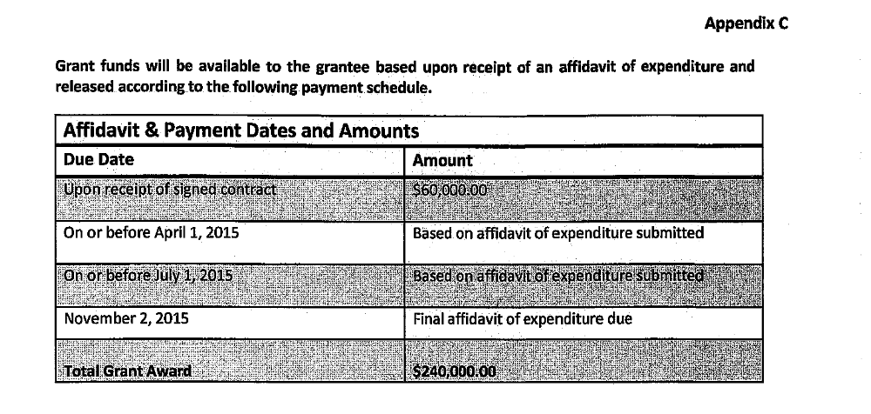

On motion (14-316) of Commissioner Moody and the second of Commissioner Wood to approve the Contract between the Kansas Department of Health and Environment and Crawford County for the planning and implementation of the 1422 Grant in Crawford County.
Yeas: Commissioners Kmiec, Moody and Wood
Nays:
Present but not voting:
Absent or not voting:
The motion prevailed.

PUBLIC HEARINGS AND OPENING OF ANNOUNCED BIDS

Item One: Public Hearing on the 2014 Crawford County Amended budget. Chairman Kmiec opened the hearing for public comment and there was none.

On motion (14-317) of Commissioner Moody and the second of Commissioner Wood to Close the Public Hearing on the 2014 Crawford County Amended Budget.
Yeas: Commissioners Kmiec, Moody and Wood
Nays:
Present but not voting:
Absent or not voting:
The motion prevailed.
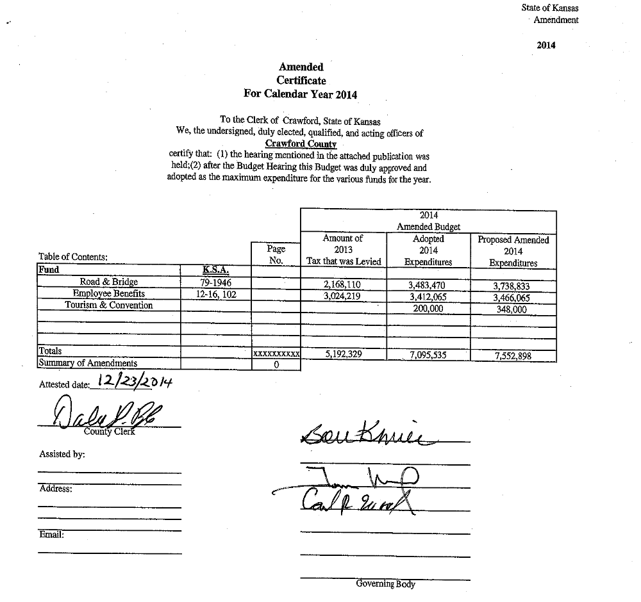

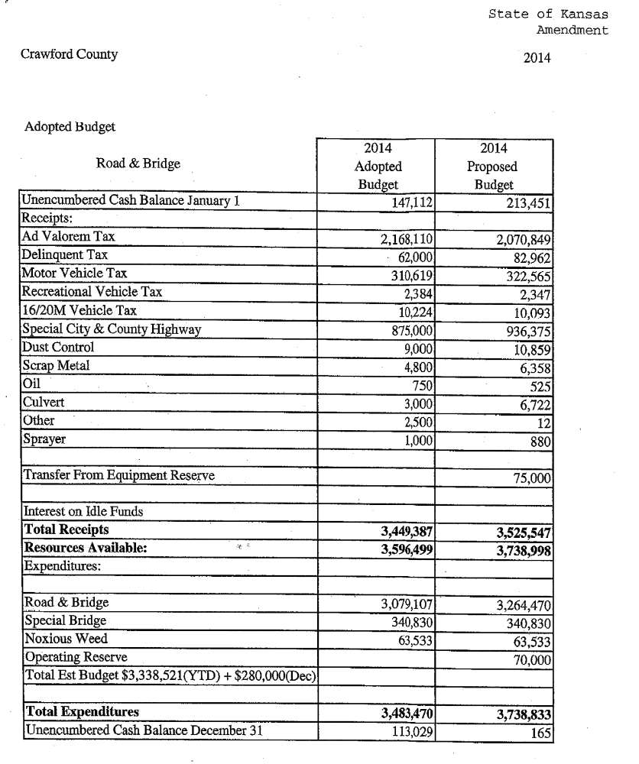
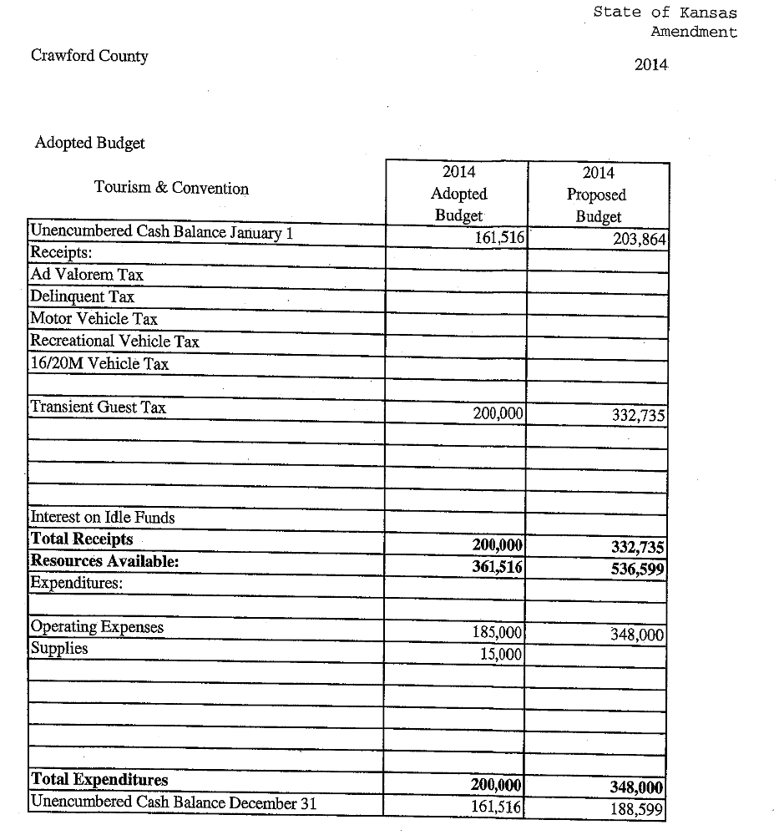
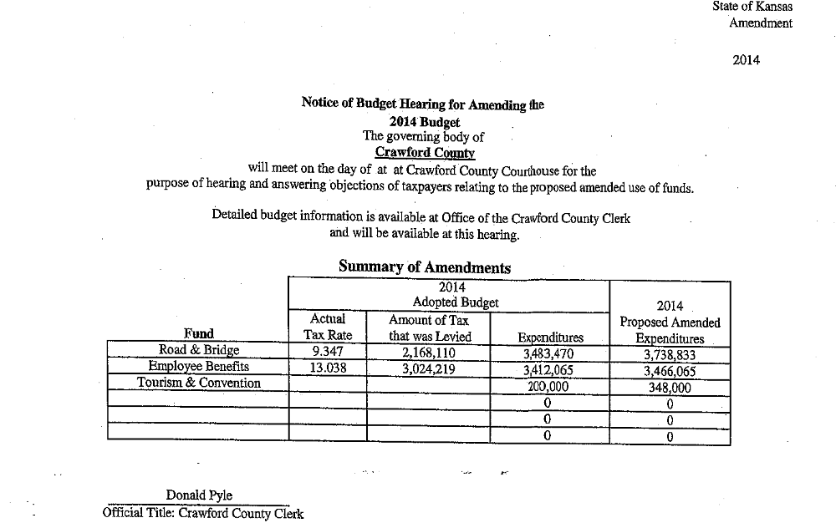
On motion (14-318) of Commissioner Moody and the second of Commissioner Wood to approve the 2014 Crawford County Amended Budget as published.
Yeas: Commissioners Kmiec, Moody and Wood
Nays:
Present but not voting:
Absent or not voting:
The motion prevailed.

MESSAGES FROM THE PUBLIC
MESSAGES FROM ELECTED OFFICIALS

Item One: Mr. Dan Peak, Crawford County Sheriff, regarding some 911 issues that are being worked on currently. Mr. Peak stated that there is an option to purchase additional interface systems that will facilitate the communication between EMS and Fire Depts. and the new CAD, Computerized Aided Dispatch, system. Mr. Joey Adams, EMS Director, discussed the ability of this system to allow all emergency personnel to communicate directly with the dispatchers in real time and to eventually make the EMS billing process much easier and more accurate. It was discussed that this system will integrate with the system used by the City of Pittsburg. There was a discussion of some of the problems with cell phone coverage in the county and with the connections between the AT&T and Craw-Kan phone systems. Mr. Peak gave the Commissioners copies of the Additional Software License Agreement which included the amounts that would need to be paid for all the different software interfaces that would be purchased. It was discussed that this total amount of $89,300 would be paid for through the 911 Funds that are received from the state for charges that are billed to all telephone customers.
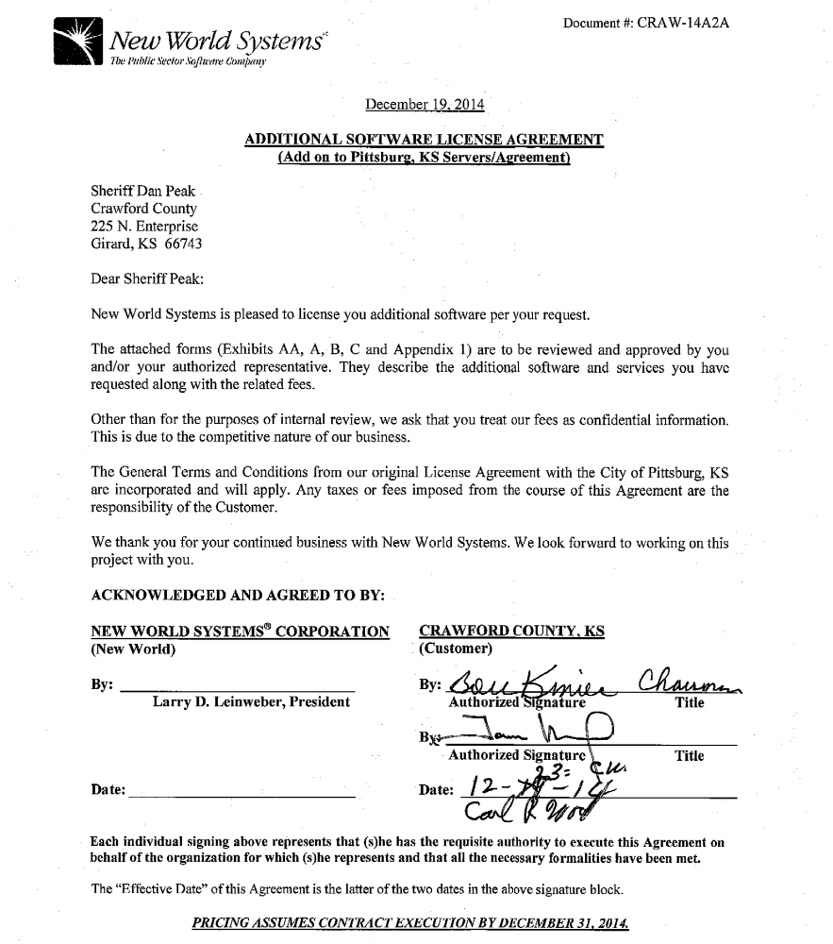

On motion (14-319) of Commissioner Wood and the second of Commissioner Moody to approve the Additional Software License Agreement and the Purchase of the Computer Aided Software System from New World Systems in the amount of $89,300.
Yeas: Commissioners Kmiec, Moody and Wood
Nays:
Present but not voting:
Absent or not voting:
The motion prevailed.

MESSAGES FROM APPOINTED OFFICIALS
EXECUTIVE SESSION

Item One: Commissioner Wood requesting an Executive Session to discuss personnel issues that involve non-elected personnel.

On motion (14-320) of Commissioner Wood and the second of Commissioner Moody to recess this open session and go into a closed executive session for a period of not more than 15 minutes to discuss personnel matters involving Non-Elected Personnel and to include the Board of County Commissioners, County Counselor Jim Emerson, Pittsburg Chamber of Commerce Executive Director Blake Benson and Members of the Convention and Visitor’s Bureau Board of Directors.
Yeas: Commissioners Kmiec, Moody and Wood
Nays:
Present but not voting:
Absent or not voting:
The motion prevailed.

The Commissioners went into Executive Session at 11:11 AM and reconvened the Open Session at 11:26 AM with no action taken except to go back into open session.

MESSAGES FROM OTHER GOVERNMENTAL ENTITIES

Item One: Mr. Blake Benson, Pittsburg Area Chamber of Commerce Executive Director, presenting 2015 CVB contract with Pittsburg Area Chamber of Commerce. Mr. Benson stated that the Chamber hopes to be the host for the CVB over the next several years and that this contract covers the cost of Mr. Harris, a full time assistant, and half of the receptionist cost that is shared with the Chamber as well as office space, supplies and other items necessary to complete the work of the Convention and Visitors Bureau. The services that are provided by the CVB were discussed.
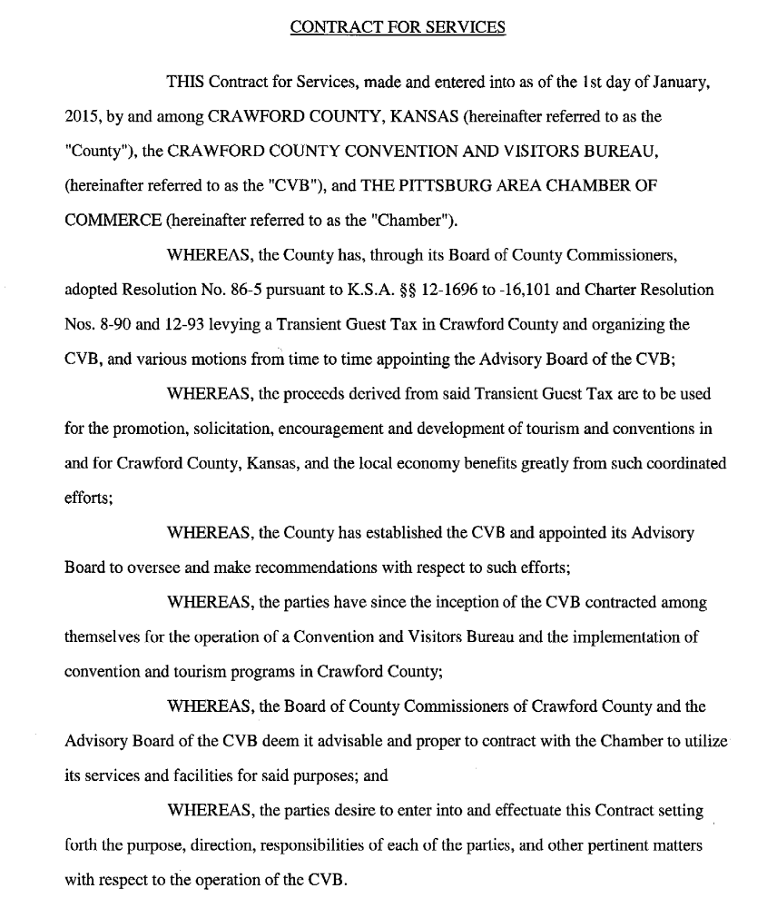
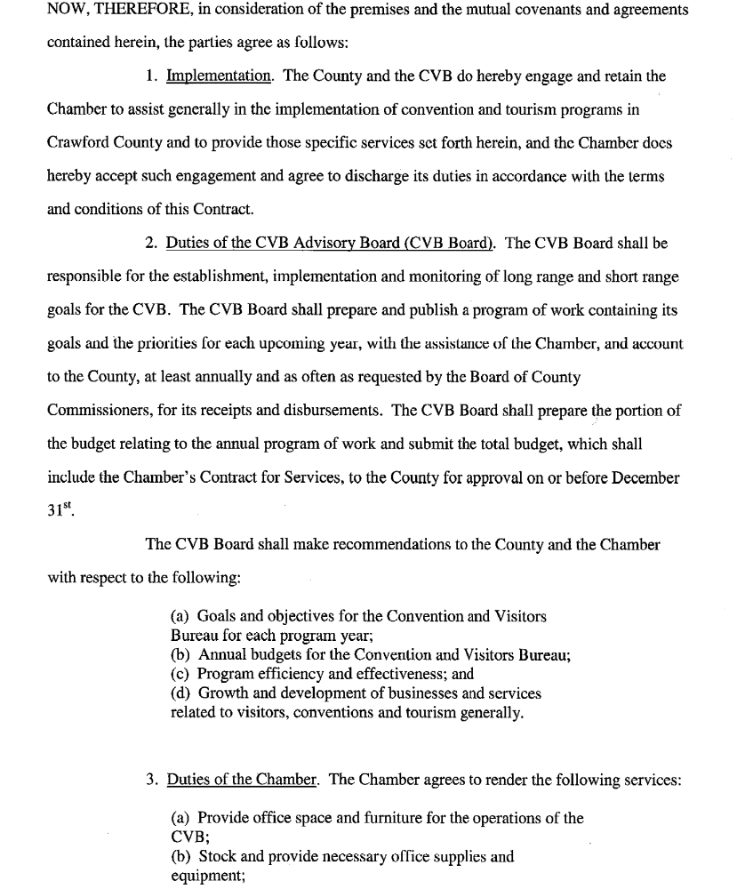

On motion (14-321) of Commissioner Moody and the second of Commissioner Wood to approve the Contract For Services between Crawford County, Kansas, and the Pittsburg Area of Chamber for the Operation of the Crawford County Convention and Visitors Bureau in the amount of $116,000 and Authorize the Chairman to Sign.
Yeas: Commissioners Kmiec, Moody and Wood
Nays:
Present but not voting:
Absent or not voting:
The motion prevailed.

Item Two: Mr. B.J. Harris, Director of the Crawford County Convention and Visitor’s Bureau, regarding the 2015 Budget for the CVB. Mr. Harris discussed the budget projections for 2014 and mentioned that the 2015 is slightly lower since Crawford County will not be hosting the Baja Event in 2015. Mr. Harris distributed a copy of the proposed budget for 2015 as well as some data on visitor spending in Crawford County in 2014. The commissioners were answered that the Multi-Purpose Event Facility at PSU will not be completed until April or May of 2015 and that they already have booked 2 NCAA Division II Indoor Track and Field Championships and that they are having a site visit from a group in conjunction with bids for hosting the Junior College Indoor Track and Field Championships in 2017 to 2019.

On motion (14-322) of Commissioner Wood and the second of Commissioner Moody to approve the 2015 Convention and Visitors Bureau Budget as presented.
Yeas: Commissioners Kmiec, Moody and Wood
Nays:
Present but not voting:
Absent or not voting:
The motion prevailed.

PROCLAMATIONS AND ORDERS OF THE BOARD
NEW BUSINESS:

Item One: County Clerk Don Pyle presenting applications for 2015 Cereal Malt Beverage Licenses for George C Brown Post 26 “Girard American Legion” and W. Esposito Enterprises, LLC for “Weeges 1 Stop” to allow them to sell cereal malt beverages. Mr. Pyle stated that “Girard American Legion” is for consumption on the premises and “Weeges 1 Stop” is for sale in original and unopened containers and not for consumption on the premises. Mr. Pyle stated that notices have been sent to the Sheriff, Zoning Administrator, County Attorney and the Township Clerk and that they had been given 10 days to respond and that no responses had been received.

On motion (14-323) of Commissioner Moody and the second of Commissioner Wood to make it known that the matter of issuing a license to the applicant(s) listed below was discussed and considered by the Board, and there being no objection filed as provided by law and the Board knowing of no reason why a license should not be issued, the board hereby issues a license to “sell at retail”, cereal malt beverages in broken case lots from the place of business as shown in the application as designated and described on the application as herein before set out, and that the County Clerk be hereby authorized and directed to execute the proper license which shall be signed by the Chairman of the Board of County Commissioners and the County Clerk of Crawford County, Kansas.

2015 Cereal Malt Beverage Licenses

APPLICANT: George C Brown Post 26 “Girard American Legion”
PREMISES: 144 E 47 Hwy, Girard, KS
(For consumption on the premises)

APPLICANT: W. Esposito Enterprises, LLC for “Weeges 1 Stop”
PREMISES: 401 N 69 Hwy, Arma, KS
(For sale in original and unopened containers and not for consumption on the premises)

Yeas: Commissioners Moody, Kmiec and Wood
Nays:
Present but not voting:
Absent or not voting:
The motion prevailed.

UNDER THE HEADING OLD BUSINESS
EXECUTIVE SESSION

Item One: Commissioner Wood requesting an Executive Session to discuss personnel issues that involve non-elected personnel.

On motion (14-324) of Commissioner Wood and the second of Commissioner Kmiec to recess this open session and go into a closed executive session for a period of not more than 30 minutes to discuss personnel matters involving Non-Elected Personnel and to include the Board of County Commissioners, County Counselor Jim Emerson, Commercial Appraiser Ryan Varsolona and County Appraiser Mike Montgomery.
Yeas: Commissioners Kmiec, Moody and Wood
Nays:
Present but not voting:
Absent or not voting:
The motion prevailed.

The Commissioners went into Executive Session at 11:50 AM and reconvened the Open Session at 12:05 AM with no action taken except to go back into open session.

Under the heading future business and announcements

FUTURE BUSINESS:

ANNOUNCEMENTS:

Item One: December 24, 25 & 26, 2014 – The Courthouse and other county offices will close at 2:00 pm on December 24, 2014 and all day on December 25 & 26, 2014 in observance of the Christmas Holiday. The Commission Meeting on December 26, 2014 is cancelled.

Item Two: December 31, 2014 – The Crawford County Courthouse will close for the Annual Cash Audit at 10:00 AM, the Register of Deeds Office will be open until 10:00 AM but no documents will be recorded due to computer updates and the Motor Vehicle Offices will be closed all day.

Item Three: January 1, 2015 – The Crawford County Courthouse and all County Offices will be closed for New Year’s Day.

UNDER THE HEADING MOTION TO ADJOURN
MOTION TO ADJOURN

Item One: Adjournment

On the motion of Commissioner Moody and the second of Commissioner Wood to adjourn the December 23, 2014 meeting of the Board of Crawford County Commissioners at 12:06 AM and to reconvene at the next regularly scheduled time with open doors.
Yeas: Commissioners Moody, Kmiec and Wood
Nays:
Present but not voting:
Absent or not voting:
The motion prevailed.

In Testimony whereof, I have hereunto set my hand and caused to be affixed my official seal and submitted these minutes for the approval of the Board of Crawford County Commissioners:

__________________________
Don Pyle
County Clerk

<>

This submission completed at the Crawford County Courthouse in Girard.
Taken by DPP 12/23/14 at 12:06 AM, Amended by DPP 12/23/14 at 4:38 PM/amended BKW 12/29/2014 3:27:59 PM

