Commissioners’ Journal

2015, FORTIETH MEETING

CRAWFORD COUNTY COURTHOUSE, COMMISSIONERS’ BOARD ROOM
Girard, KS Tuesday, June 2, 2015, 10:00 AM

The Crawford County Board of Commissioners met pursuant to Kansas Statutes

Annotated Chapter 19, Article 2, Section 18 in due and regular session with open doors.

Commissioner Carl Wood served as the presiding officer.

Commissioners Jeff Murphy and Tom Moody were in attendance.

County Clerk Don Pyle and County Counselor Jim Emerson were seated with the Board.

Chairman Wood led the pledge of allegiance.

UNDER THE HEADING BUSINESS FROM A PREVIOUS MEETING
CONSENT AGENDA
On motion (15-156) of Commissioner Moody and the second of Commissioner Wood that the consent agenda be approved including:
- Approval of the May 26, 2015 minutes of the Board of Commissioners.
Yeas: Commissioners Moody, Murphy and Wood
Nays:
Present but not voting:
Absent or not voting:
The motion prevailed and the consent agenda was approved.

SIGNING OF MOTIONS

The County Clerk presented the following motions for Commissioners’ signatures:

Motion 15 | 152 | That the consent agenda be approved including: Approval of the May 22, 2015 minutes
Motion 15 | 153 | To recess this open session and go into a closed executive session for a period of not more than 10 minutes to discuss Preliminary Matters related to the Acquisition of Real Property and to include the Board of County Commissioners, Andrew Nash and County Counselor Jim Emerson.
Motion 15 | 154 | To recess this open session and go into a closed executive session for a period of not more than 30 minutes to discuss matters that could be deemed to privileged in the Attorney-Client Relationship and to include the Board of County Commissioners, Attorney Terrelle Mock and County Counselor Jim Emerson
Motion 15 | 155 | To recess this open session and go into a closed executive session for a period of not more than 60 minutes to discuss matters that could be deemed to privileged in the Attorney-Client Relationship and to include the Board of County Commissioners and County Counselor Jim Emerson

UNDER THE HEADING NEW BUSINESS
PRESENTATION OF PLAQUES TO RETIRING EMPLOYEES

Item One: Plaques were presented to retiring county employees Judy Freeman and Mike Montgomery. Commissioner Wood presented a plaque to Mike Montgomery in appreciation of his 28 years of service to Crawford County. Commissioner Moody presented a plaque to Judy Freeman in appreciation of her 27 years of service to Crawford County. All of the Commissioners thanked both of them for their dedication and service to the citizens of Crawford County.

CRAWFORD COUNTY BOARD OF HEALTH
PUBLIC HEARINGS AND OPENING OF ANNOUNCED BIDS

Item One: Public Hearing on closing and vacating a portion of platted Maple Street in the Original Town of Opolis, Crawford County, Kansas.

Chairman Wood opened the public hearing. No one from the public wished to make any comments either for or against the closing and vacating of this street.

On motion (15-157) of Commissioner Moody and the second of Commissioner Wood to close the public hearing on closing and vacating a portion of platted Maple Street in the Original Town of Opolis, Crawford County, Kansas.
Yeas: Commissioners Wood, Moody and Murphy
Nays:
Present but not voting:
Absent or not voting:
The motion prevailed.

Mr. Jim Emerson presented Resolution #2015-017, a Resolution closing and vacating a portion of platted Maple Street in the Original Town of Opolis, Crawford County, Kansas described as a portion of Maple Street located adjacent to and east of Lots 1-4, Block 27 and adjacent to and west of Lots 14-26, Block 28 in the Original town of Opolis, Crawford County, Kansas according to the recorded plat thereof.
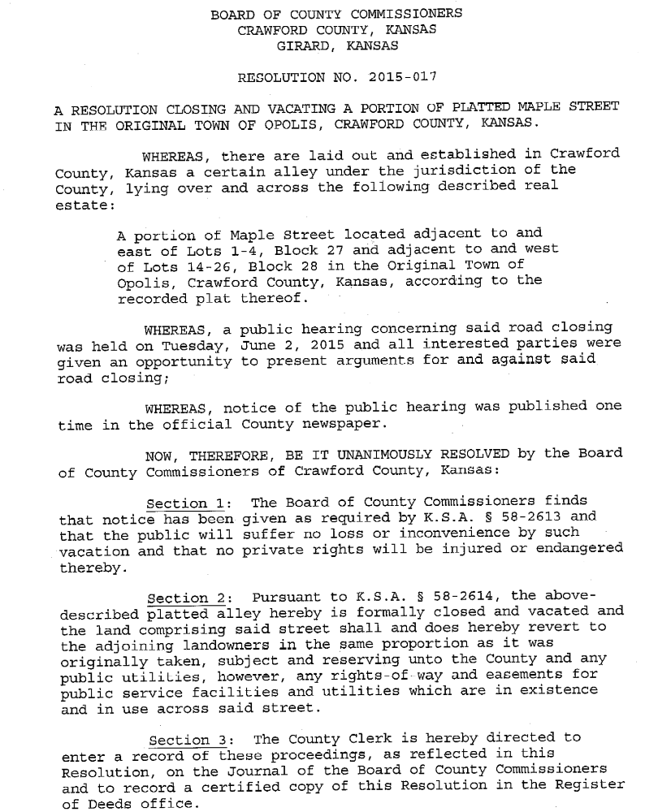
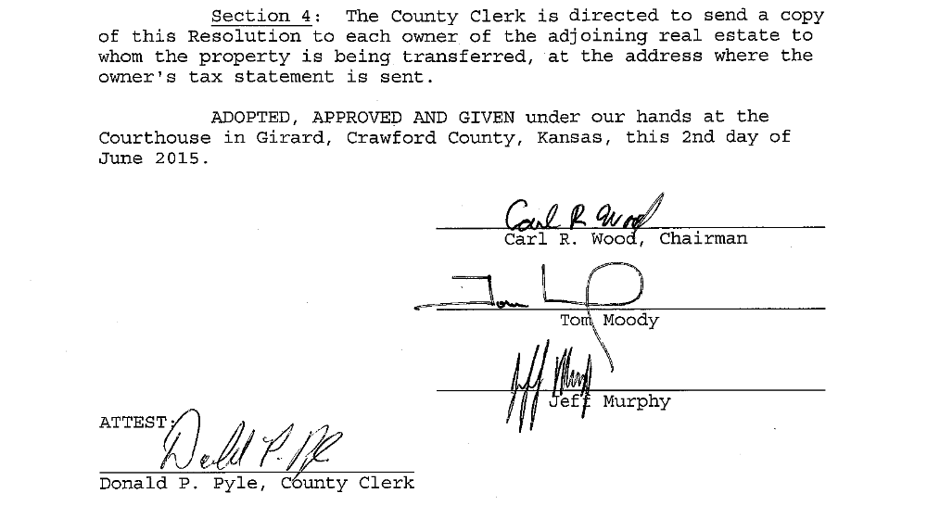

On motion (15-158) of Commissioner Moody and the second of Commissioner Wood to adopt Resolution #2015-017, a Resolution closing and vacating a portion of platted Maple Street in the Original Town of Opolis, Crawford County, Kansas described as a portion of Maple Street located adjacent to and east of Lots 1-4, Block 27 and adjacent to and west of Lots 14-26, Block 28 in the Original town of Opolis, Crawford County, Kansas according to the recorded plat thereof.
Yeas: Commissioners Wood, Moody and Murphy
Nays:
Present but not voting:
Absent or not voting:
The motion prevailed.

Item Two: Public Hearing on closing and vacating Mine Street in the Original Town of Alston, Crawford County, Kansas.

Chairman Wood opened the public hearing. No one from the public wished to make any comments either for or against the closing and vacating of this street.

On motion (15-159) of Commissioner Moody and the second of Commissioner Wood to close the public hearing on closing and vacating Mine Street in the Original Town of Alston, Crawford County, Kansas.
Yeas: Commissioners Wood, Moody and Murphy
Nays:
Present but not voting:
Absent or not voting:
The motion prevailed.

Mr. Jim Emerson presented Resolution #2015-018, a Resolution closing and vacating Mine Street in the Original Town of Alston, Crawford County, Kansas described as Mine Street located South of and adjacent to Lots 41-45 in the Original Town of Alston, Crawford County, Kansas, according to the recorded plat thereof.
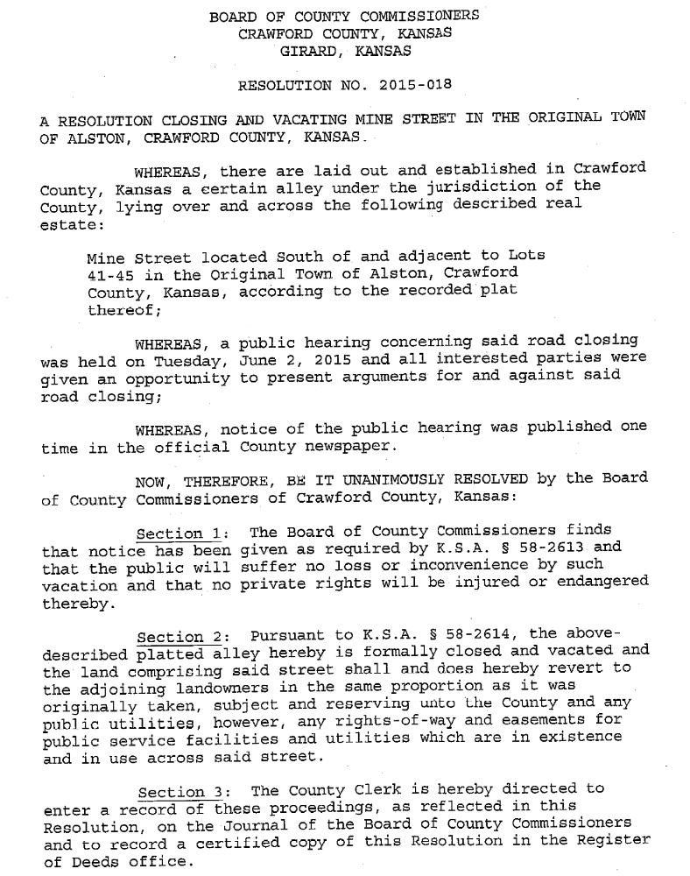
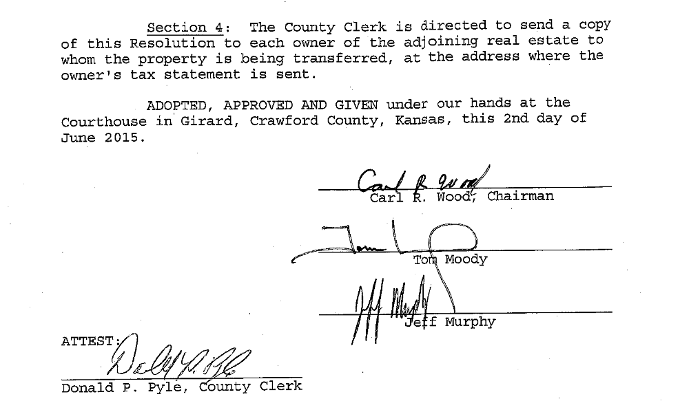

On motion (15-160) of Commissioner Moody and the second of Commissioner Wood to adopt Resolution #2015-018, a Resolution closing and vacating Mine Street in the Original Town of Alston, Crawford County, Kansas described as Mine Street located South of and adjacent to Lots 41-45 in the Original Town of Alston, Crawford County, Kansas, according to the recorded plat thereof.
Yeas: Commissioners Wood, Moody and Murphy
Nays:
Present but not voting:
Absent or not voting:
The motion prevailed.

MESSAGES FROM THE PUBLIC
MESSAGES FROM OTHER GOVERNMENTAL ENTITIES
MESSAGES FROM APPOINTED OFFICIALS

Item One: Mr. Eldon Bedene, Emergency Management Director, regarding any damage to roads or other infrastructure that might have occurred in the recent wave of storms. Mr. Bedene stated that several of the neighboring counties have declared a disaster so that if the state receives a presidential declaration of disaster, the county can be reimbursed for up to 75% of the materials and equipment expenses of the county and for any overtime that might have been incurred in responding to damage from the recent storms.
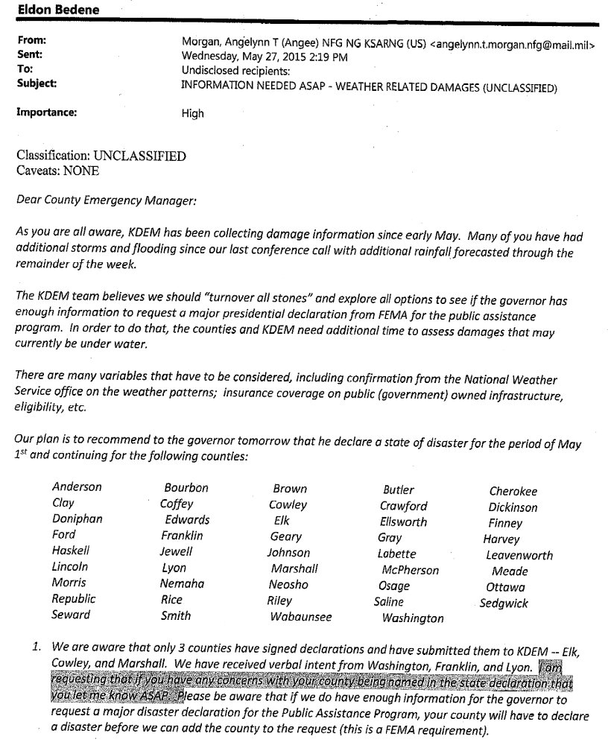
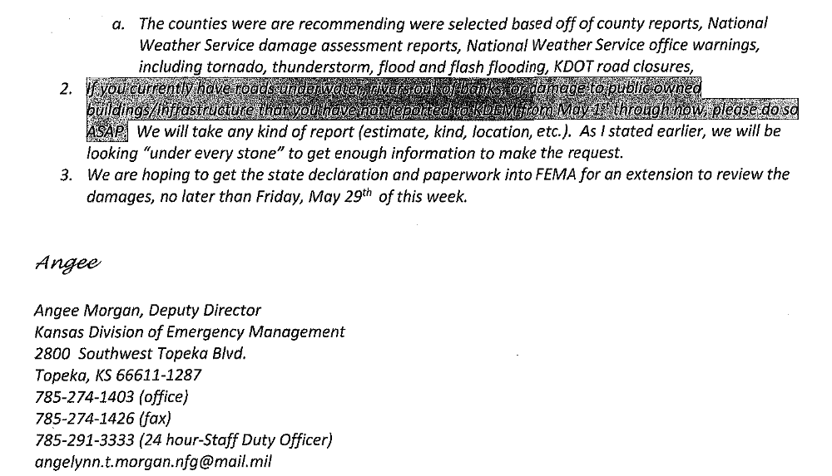
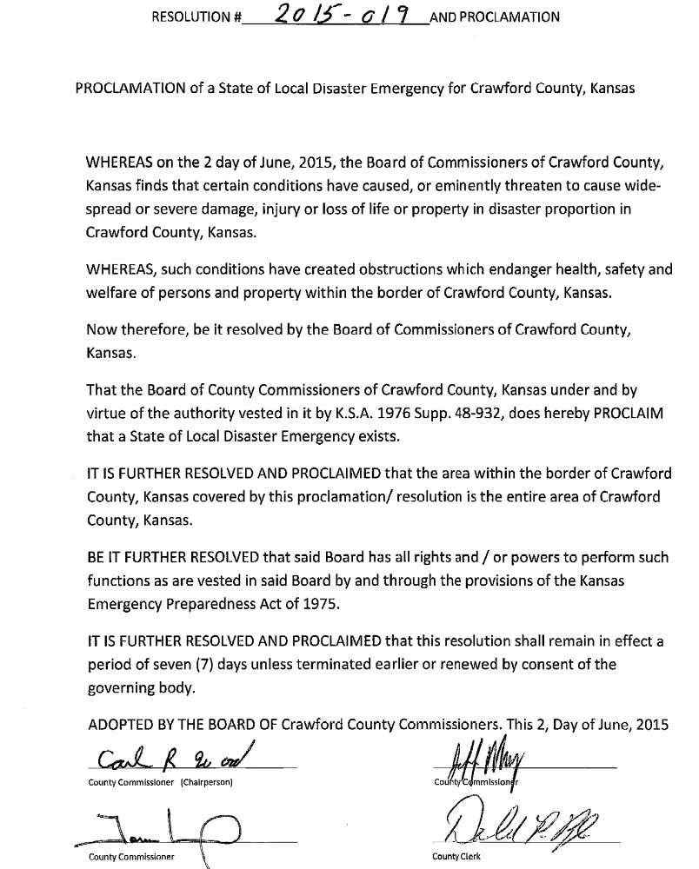

On motion (15-161) of Commissioner Moody and the second of Commissioner Wood to adopt Resolution #2015-019, a Resolution declaring a State of Local Disaster Emergency in Crawford County, Kansas.
Yeas: Commissioners Wood, Moody and Murphy
Nays:
Present but not voting:
Absent or not voting:
The motion prevailed.

Item Two: Mr. Eldon Bedene, Emergency Management Director, regarding some damage to the county vehicle that he drives from a collision with a hawk. Mr. Bedene stated that he had obtained a couple of estimates to repair the damage and he wanted the Commissioners to approve the repair work. The Commissioners discussed that this would come out of the Emergency Management budget and they directed Mr. Bedene to get the repair work done.
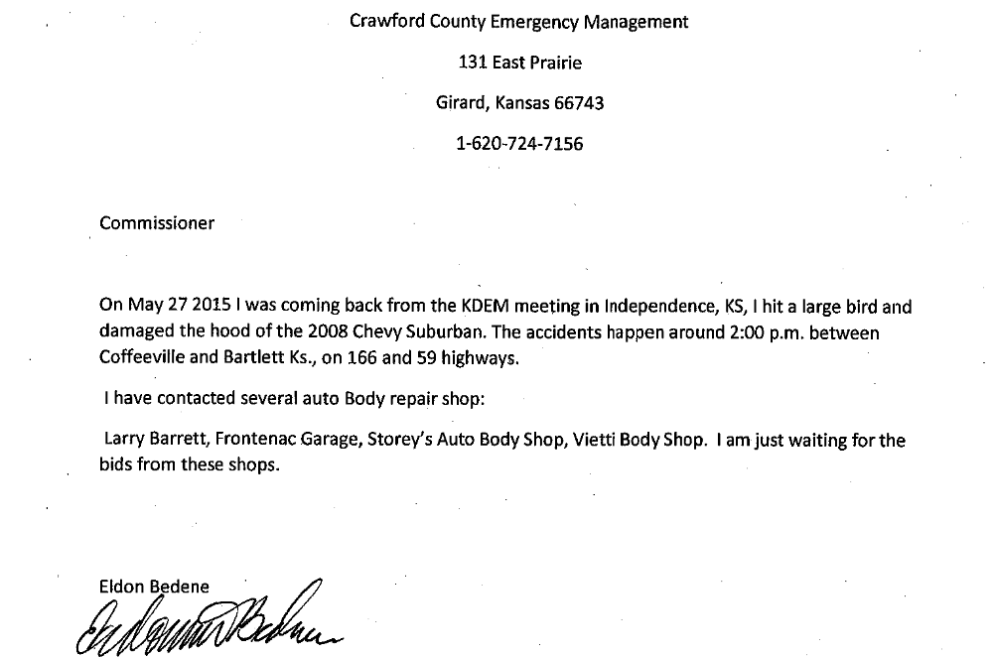

MESSAGES FROM ELECTED OFFICIALS
PROCLAMATIONS AND ORDERS OF THE BOARD
NEW BUSINESS

Item One: County Clerk Don Pyle presenting the May 2015 Clerk’s Report. Mr. Pyle stated that it summarizes the total amounts spent by departments for payroll and other bills during the month of May. Mr. Pyle also gave the Commissioners a copy of the April 2015 to May 2015 Clerk’s Report of Changes in Expenditures for comparison. There was a discussion of the reasons behind some of the fluctuations in spending.

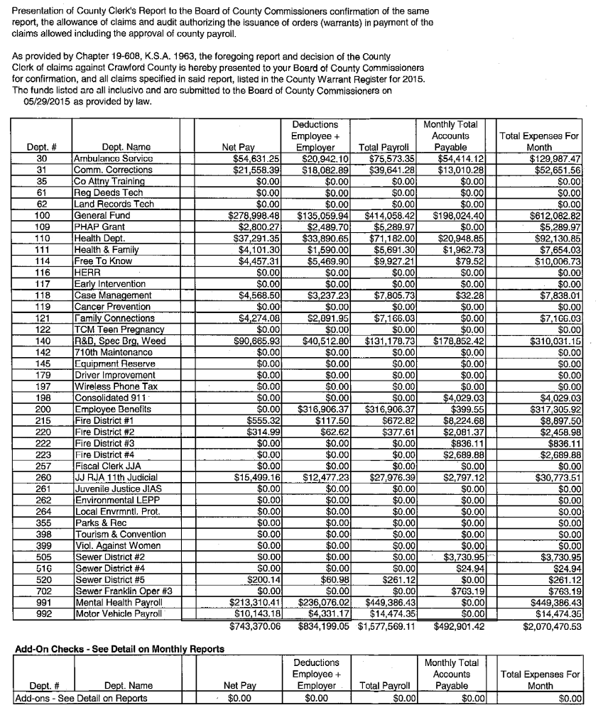
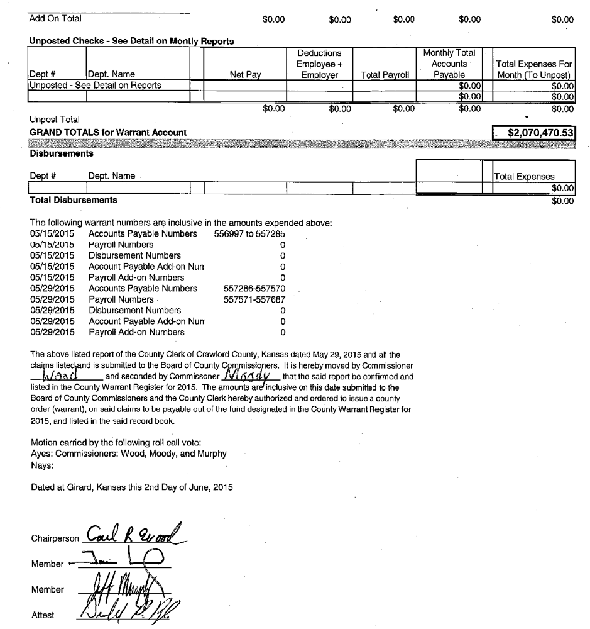
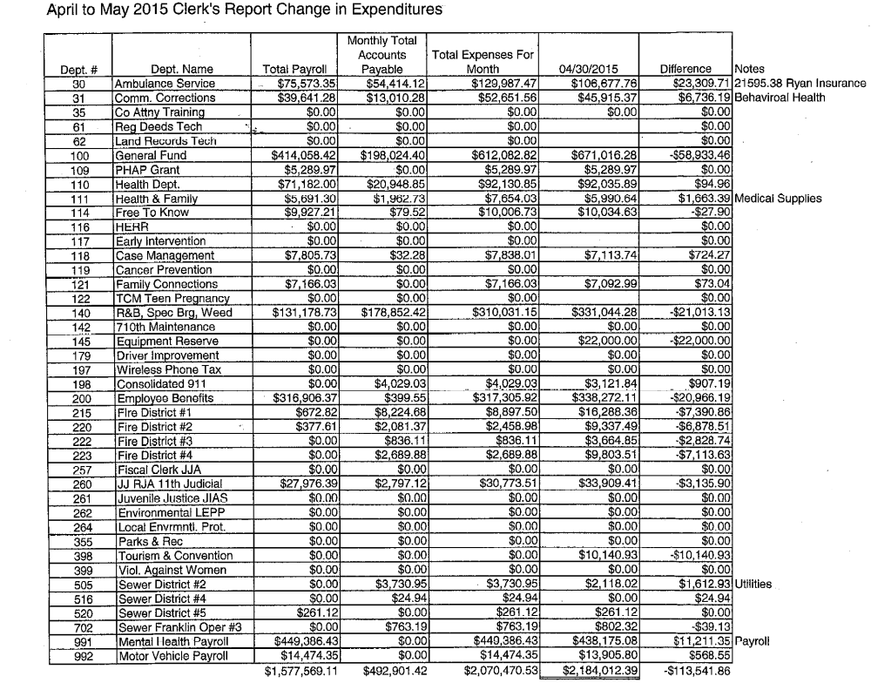
On motion (15-162) of Commissioner Wood and the second of Commissioner Moody to approve the May 2015 Clerk’s Report.
On a Roll Call Vote.
Yeas: Commissioners Wood, Moody and Murphy
Nays:
Present but not voting:
Absent or not voting:
The motion prevailed.

Item Two: County Clerk Don Pyle regarding a proposed schedule for the fees for the different types of cereal malt beverage licenses. Mr. Pyle stated that his office had worked with the Crawford County Fair Board and the Girard American Legion so that both of those organizations could hold a license to sell cereal malt beverages at the fairgrounds. The Fair Board holds a license for that location for the year and then the American Legion can obtain a special event permit to allow them to sell cereal malt beverages during the Crawford County Fair only. There was a discussion of the different types of CMB permits and how they work together. Mr. Pyle asked that the Commissioners approve a schedule of the amounts to be charged for the different permits.

On motion (15-163) of Commissioner Moody and the second of Commissioner Wood to Cereal Malt Beverage Permit Fees as presented by the Crawford County Clerk.
Yeas: Commissioners Wood, Moody and Murphy
Nays:
Present but not voting:
Absent or not voting:
The motion prevailed.

Item Three: County Clerk Don Pyle regarding a message that could be sent out to Elected Officials and Department Heads to request some information on amounts that they would like to transfer to an equipment reserve fund if there is one available. There was a discussion of this proposed equipment reserve fund and some of the challenges that it will present. The Commissioners decided to schedule a work session with the elected officials and department heads to discuss the proposed equipment reserve fund.

Item Four: Commissioner Murphy regarding some information that he has seen from the Bukaty Group on putting together a Group Captive Health Insurance Pool. Mr. Murphy stated that this pool is designed to help with the cost of the stop-loss insurance for the county group health insurance. It was discussed that the Bukaty Group is working with KAC to help look at ways to lower the cost of health insurance for counties.

Item Five: Commissioner Murphy regarding a request from the Live Well Crawford County to be allowed to put up some road signs in the county. Mr. Murphy stated that they also expressed interest in seeing if the county could install the signs and possibly to design and build some of the signs. There was a discussion of the possibility of the county being liable for some issues if the county puts up their signs. It was decided to invite the Live Well group to come discuss this with the Commissioners.

UNDER THE HEADING OLD BUSINESS

Item One: Commissioner Murphy regarding the Museum Task Force. Mr. Murphy stated that the group met last week, but it was before they knew that the Crawford County Historical Society was discontinuing their operations. Mr. Murphy stated that the board of the Miners Hall Museum expressed interest in the operations of the Crawford County Museum but they also stated that they did not think they could move their current operations to the Pittsburg location. Mr. Tom Ragonese discussed the current state of the buildings and that they are secure and that the artifacts are still in a controlled climate and that they are safe. There was a discussion of some of the current operating issues of that location. Commissioners Moody and Murphy both stated that they have received inquiries from people that have an interest in running this facility. It was discussed that funding continues to be the most critical issue facing this facility. There was a discussion of the importance of obtaining a list of the items that are in the possession of the museum. It was also discussed that it is important to be sure that this facility is insured. Mr. Murphy was going to schedule another meeting of the Museum Task Force to discuss this situation and to discuss the future of this facility.

Item Two: Commissioner Wood regarding some information on a possible lease purchase for a tractor and mower. Mr. Wood discussed the lease purchase program being offered through the State of Kansas and that it requires that the equipment be purchased through a lease purchase program in order to get the state discount. There was a discussion of this purchase and that some of this could come from the equipment reserve fund. Mr. Wood was going to find out if the lease can be paid off early and there was a discussion of the restrictions on municipalities in regards to multi-year lease purchases.

EXECUTIVE SESSION

Item One: County Counselor Jim Emerson asked for a work session to discuss matters that would be deemed privileged in the Attorney-Client Relationship.

On motion (15-164) of Commissioner Moody and the second of Commissioner Wood to recess this open session and go into a closed executive session for a period of not more than 30 minutes to discuss matters that could be deemed to privileged in the Attorney-Client Relationship and to include the Board of County Commissioners, Attorney Terrelle Mock and County Counselor Jim Emerson.
Yeas: Commissioners Moody, Murphy and Wood
Nays:
Present but not voting:
Absent or not voting:
The motion prevailed.

The Commissioners went into Executive Session at 11:45 AM and reconvened the Open Session at 12:15 PM with no action taken except to go back into open session.

Under the heading future business and announcements
FUTURE BUSINESS:

ANNOUNCEMENTS:

Item One: June 9, 9:00 AM – Work Session with Elected Officials and Department Heads to discuss the proposed Equipment Reserve Fund.

UNDER THE HEADING MOTION TO ADJOURN
MOTION TO ADJOURN
Item One: Adjournment

On the motion of Commissioner Moody and the second of Commissioner Murphy to adjourn the June 2, 2015 meeting of the Board of Crawford County Commissioners at 12:20 PM and to reconvene at the next regularly scheduled time with open doors.
Yeas: Commissioners Moody, Murphy and Wood
Nays:
Present but not voting:
Absent or not voting:
The motion prevailed.

In Testimony whereof, I have hereunto set my hand and caused to be affixed my official seal and submitted these minutes for the approval of the Board of Crawford County Commissioners:

__________________________
Don Pyle
County Clerk

<>

This submission completed at the Crawford County Courthouse in Girard.
Taken by DPP 06/02/2015 at 12:20 PM, Amended by DPP 06/03/2015 at 3:46 PM/amended BKW 06/04/2015 1:43 PM

